As the gaming medium has evolved, game designers have become more and more ambitious with their desired player experiences. Many early games (such as *Space War*, or *Pong*) were meant purely for friendly competition; later titles, like *The Oregon Trail*, were designed to educate the player about a specific topic. (The aforementioned example was designed by a middle-school history teacher who needed an engaging way to teach a lesson on westward American expansion.) This genre of games was initially dubbed "edutainment games" (as they were a clever blend of education and entertainment). Nowadays, since the lessons of these games have moved away from fundamental concepts like math and history and towards more nuanced subjects like immigration control or the horrors of war, games like these are referred to as "serious games".

The interactivity of these serious games gives them an inherent advantage over other mediums (i.e. television, film, literature, etc.). Through the power of games, a player could be tasked with making decisions about a situation *totally* foreign to anything they've ever experienced. Because the player has the agency to maneuver and manipulate this unfamiliar situation, they'll be much more intimately impacted by the outcome of a decision than they might have if they had simply just watched a film character make that decision. Thanks to the nuance of interactivity, the power of games has been harnessed to teach a variety of lessons to players.

As follows is a brief examination of some more recent serious games; each examination will highlight:

* The intended lesson of the game
* Specific mechanics / moments in the game that help teach this lesson
* How we could take inspiration from this game to inform the design of our game

Hopefully, after reading some of these, you'll have a better idea of how games are able to accomplish teaching players about complex situations, and how our game might fit into this categorization.

### 

### ***Life is Strange 2***

*Life is Strange 2* is a 2018 game developed by Dontnod Entertainment. Despite being a sequel to their 2015 release, *Life is Strange*, the game's plot revolves around an entirely different cast of characters. *Life is Strange 2'*s gameplay resembles that of a choose-your-own-adventure novel: players progress through the story by making decisions about what they think Daniel (the story's protagonist) ought to do.



Decisions made have a varying range of impact on the story - certain decisions will unlock totally new narrative branches, while others might serve only to heighten the player's sense of agency. *Life is Strange 2* is not unique for its narrative structure; the gameis a member of a growing classification of games referred to as "narrative games", a genre where the core gameplay mechanic is making decisions to influence the direction of the plot. Instead, the game manages distinguishes itself from its peers by choosing to tackle some real world issues, such as police brutality and racism.

Unlike some other narrative games, which are set in fantastical fictional worlds, *Life is Strange 2* takes place in 2016's America, a month before the Trump election. The main character, Daniel, is Mexican-American, and players are exposed to Daniels' family's anxieties about how a win for Trump might impact their lives. Racial tensions are further explored as the story unfolds, as Daniel and his brother cope with the aftermath of police brutality, and are exposed to numerous instances of discrimination.

Dontnod could have managed to tell a story about racism without referencing real-world events - tons of fictional works have successfully achieved this. The inclusion of mentions to these events hugely paid off, though, as the game feels *incredibly* relevant and timely - players are shown just how challenging navigating present-day America as a person-of-color can be. The realism of the story’s context works to create a more convincing world, which further pushes the player to think about their place in their own world.

For our own ethics game, we’ve taken huge inspiration from the branching plotlines of the narrative game format - we want players of our game to make decisions about certain ethical situations, and we want to show them how their decisions impact the world around them. *Life is Strange 2*’s inclusion of real-world events offers further insight for the design of our narrative - in order to make our experience more impactful and memorable, we ought to try to reference real events.

### ***Papers, Please***

*Papers, Please* is a 2013 game developed by indie company 3909 Games; in it, players assume the role of an immigration officer reviewing papers of potential entrants into the fictional country of Arstotzka. The core gameplay loop consists of players checking entrants' documents, comparing them to the ever-growing immigration standards to search for discrepancies, and making a decision to reject or approve their entry into the country.

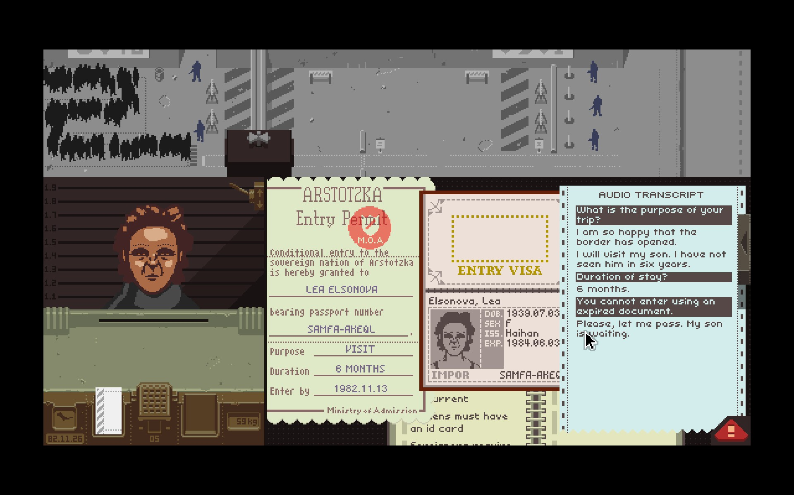

Players receive a wage at the end of their workday, and this wage will raise or lower depending on how many entrants were "correctly" admitted into the country; naturally, then, players are incentivized to enforce the immigration standards as strictly as possible in order to maximize their wage. Constantly, though, the player will be met with moral dilemmas about whether to let people through: an entrant could be a former prostitute trying to escape persecution from their pimp, or a wife wrongly separated from her husband by the government that's just trying to come back home. Players have to balance their own morals with their desire to get a higher wage.

That moral dilemma alone could be enough to warrant *Papers, Please* as a serious game; the developers took it a step further, though, and included a money-management mechanic to complement the wage mechanic. After each day at work, the player must choose how to spend their wage (whether that be on food, heat, a new apartment, etc.), and since border patrol isn't the most lucrative position, there isn't a whole lot of money to go around. The players' character needs to provide care to their family - choosing to skip out on a heat payment one day might lead to the player's son becoming sick a few days later. In this way, the wage mechanic becomes much more meaningful and realistic, and the decision to bend the rules to allow illegal entrance to someone in need becomes a lot harder to make.

When designing our ethics game, this is a particular point we want to focus on. It's easy to always think about "doing the right thing" when it comes to any workplace ethical dilemma, even if if may put you on unshaky ground in the eyes of your employer; once you consider some of these external factors, though, the decision to risk a working wage over "doing the right thing" becomes a trickier decision. *Papers, Please* was able to successfully gamify this dilemma, and the game is all the more memorable because of it.

### ***Spec Ops: The Line***

*Spec Ops: The Line* is a 2011 war shooter developed by Yaeger Development. Players control an army captain named Martin Walker, who's been sent on a rescue mission in an alternate history Dubai that's been ravaged by natural disasters. The game stood out in the saturated war shooter market for its unconventional narrative, which revolved around showcasing the "moral aspects of war."



Yaeger Development accomplishes this lofty narrative goal by slowly tweaking the game's base mechanics as the player progresses. As Captain Walker descends further into the fallen city, him and his crew begin to descend into madness. One game mechanic involves the player commanding his crew to perform certain actions. At the beginning of the game, these orders are military-standard, composed ones, like "eliminate that priority target" - later on, after warfare's psychological stress has overcome Walker, the order might be a much more aggressive, violent, "take out that son of a b*****!"

The game is *loaded* with small changes like this: character models become more bloody and ragged, enemy kills become more gruesome, and hallucinations will start to subtly creep into the moment-to-moment gameplay. Even though the gameplay mechanics themselves are consistent throughout the game, alterations to their delivery work to actively expose the deterioration of the characters' mental states. In other contemporary war shooters, the player character's behavior and interactions with their environment will remain fairly static throughout the game; by eschewing this convention, Yaeger Development hugely succeeded in showing how the horrors of war can change people.

Our ethics game will be a far cry from a military shooter, but we can still take inspiration from *Spec Ops: The Line*'s design. In order to make our messages have impact, every element of the game ought to react in some way to the development of the plot; for instance, maybe a co-worker could become less likely to talk to you about work if they think you're at risk for being fired, as they're nervous of associating themselves with your actions. If every aspect of a game is informed by plot development, than the plot itself will resonate much more.